
Final REPORT
AIL303m

Apply Machine Learning in Bomberman game using Reinforment Learning

FPT University
HO CHI MINH CITY

June 22, 2025

Leature:
MsC Luu Giang Nam

Student:
Dang Thanh Tuan : SE
Ha Quang Hieu : SE

Contents
Contents 1
1. Introduction 2
2. Background 3
2.1 Machine learning 3
2.2 Reinforcement learning 3
2.3 Markov Decision Process (MDP) 4

- Introduction
This project applies Reinforcement Learning (RL), specifically Q-learning, to train an agent to play the classic game Bomberman. The goal is for the agent to learn optimal behaviors such as avoiding bombs, defeating enemies, and collecting coins — all through trial and error without human-labeled data.
Bomberman is a grid-based environment that requires real-time decision-making, making it an ideal testbed for RL. In our approach, the agent interacts with the game environment, receives rewards or penalties, and gradually improves its policy over time. We design a custom state representation, reward function, and evaluate performance through win rate and survival time.
This project demonstrates how RL can be used to create intelligent game agents and provides practical insights into applying machine learning in dynamic, rule-based environments.

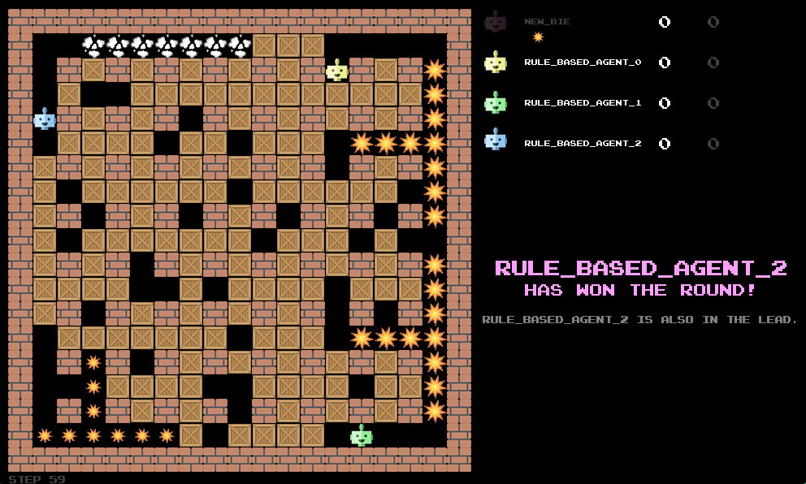
Figure 1: Bomberman game

- Background
  - Machine learning
Machine Learning (ML) is a subset of artificial intelligence (AI) that enables computers to learn patterns from data and make decisions or predictions without being explicitly programmed for specific tasks.
At its core, machine learning focuses on building models that can generalize from past experiences (data) to make accurate decisions on new, unseen data.

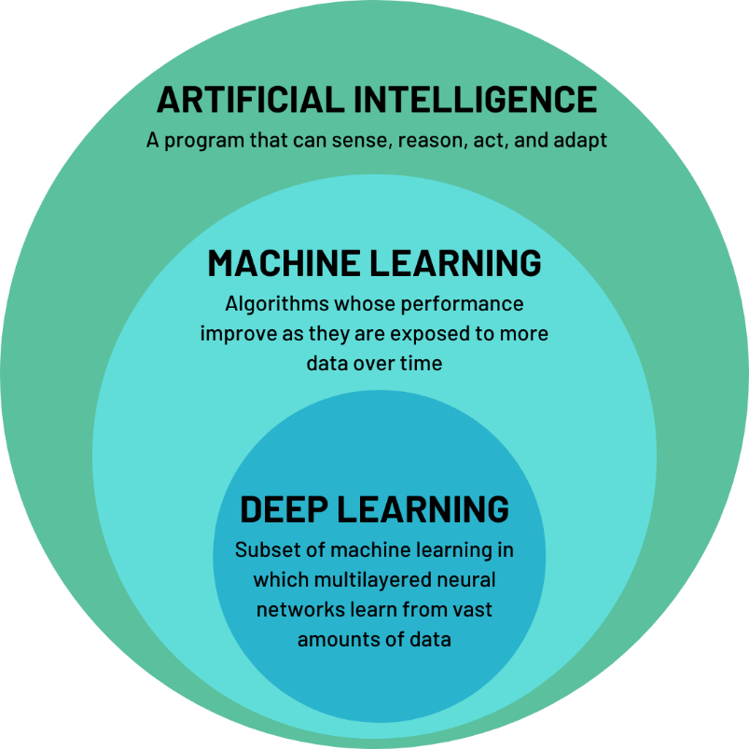
Figure 2: What is machine learning

  - Reinforcement learning
Reinforcement Learning is a branch of machine learning where an agent learns how to make decisions by interacting with an environment. The agent observes the current state, selects an action, receives a reward, and transitions to a new state.

The objective of the agent is to learn a policy that maximizes the cumulative long-term reward.
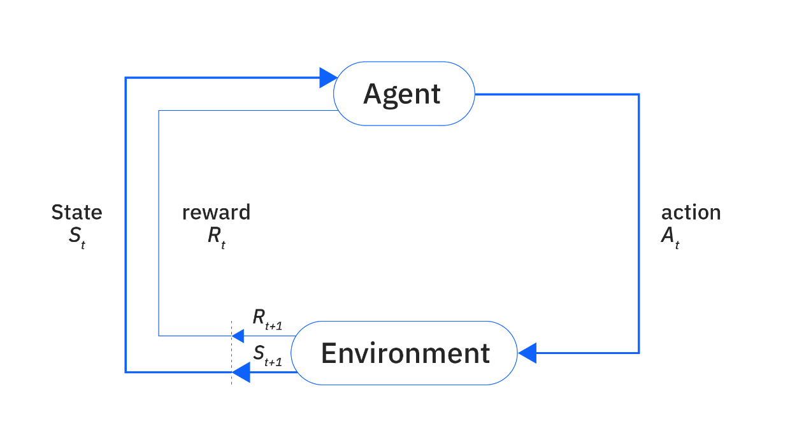
Figure 3: Overview reinforcement learning

  - Markov Decision Process (MDP)
A Markov Decision Process (MDP) is a mathematical framework used to model decision-making in environments where outcomes are partly random and partly under the control of a decision-maker (agent). It provides the foundation for most reinforcement learning (RL) algorithms.
An MDP is formally defined as a tuple:
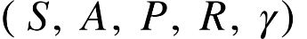
Where:
- : A finite set of states the agent can be in.
- 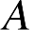: A finite set of actions the agent can take.
- 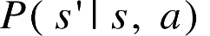: The transition probability — the probability of reaching state s’ after taking action aaa in state s.
- 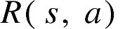: The reward function, giving the immediate reward received after performing action aaa in state s.
- (gamma): The discount factor, 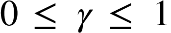, which determines the importance of future rewards.

The Markov property states that the next state depends only on the current state and action, not on the full history. This simplifies the learning and planning process:
This equation represents the probability of transitioning to state s′ given that the agent is currently in state s and takes action a. It captures the stochastic nature of the environment, where the outcome of an action may not be deterministic.
The Markov property allows reinforcement learning algorithms to model the environment effectively without requiring the full history of past interactions. It ensures that the state at time t contains all the necessary information to predict future states and rewards.

  - Q-learning
Q-learning is a widely used model-free reinforcement learning algorithm that enables an agent to learn the optimal action-selection policy in a Markov Decision Process (MDP). It does not require prior knowledge of the environment's dynamics and is capable of learning through direct interaction.
The core idea of Q-learning is to learn a Q-value function, denoted by Q(s,a), which estimates the expected cumulative reward of taking action aaa in state sss, and thereafter following the optimal policy.
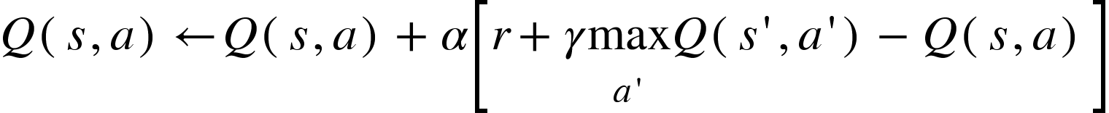
In this formula, Q(s,a) is the current Q-value for action a in state s. s is the current state, a is the action taken, and r is the immediate reward leading to the next state s′. α (learning rate) controls how new information updates Q-values, while γ (discount factor) weighs future rewards. Max a′ ​Q(s′,a′) represents the maximum estimated future reward from the next state s′, guiding the agent towards optimal decisions.
- Method
This section details the Artificial Intelligence (AI) methodologies, including traditional Reinforcement Learning (RL) and Machine Learning (ML), employed to develop and train an AI agent to play the Bomberman game. The objective is to create an agent capable of autonomously learning to make optimal decisions within the complex game environment, without relying on Deep Learning models.
  - Environment
The Bomberman game environment is defined by its State (s), represented as a vector of crucial extracted features (e.g., relative positions, bomb and item information) due to the full state space's immense size. Actions (a) include movement and bomb placement. Rewards (r) are designed to encourage desired behaviors such as destroying obstacles, eliminating opponents, and survival.
  - State
In the Bomberman game environment, the "State" (s) observed by the AI agent is a comprehensive set of detailed information about the current situation of the game round. This information is provided as a data structure (e.g., a dictionary) comprising the following components:
- 'round' (int): Indicates the number of rounds that have passed since the environment was launched, starting from 1.
- 'step' (int): Indicates the number of steps (actions) that have been taken in the current episode, also starting from 1.
- 'field' (np.array(width, height)): This is a 2D numpy array describing the tiles of the game board. The values in the array represent the type of tile:
  - 1: Crate (destructible).
  - -1: Stone wall (indestructible).
  - 0: Free tile (empty path)
- 'bombs' ([[int, int], int]): A list of tuples containing information about all active bombs. Each tuple includes:
  - The (x, y) coordinates of the bomb.
  - The countdown timer t of the bomb (where t == 0 means the bomb is about to explode).
- 'explosion_map' (np.array(width, height)): A 2D numpy array indicating, for each tile, for how many more steps an explosion will be present. A value of 0 means no explosion is present at that tile.
- 'coins' ([[x, y]]): A list of (x, y) coordinates for all currently collectible coins on the map.
- 'self' ([str, int, bool, (int, int)]): A tuple describing information about the AI agent itself:
  - n: The agent's name.
  - s: The agent's current score.
  - b: A boolean value indicating whether the 'BOMB' action is currently possible.
  - (x, y): The agent's current coordinates on the board.
- 'others' ([[str, int, bool, (int, int)]]): A list of tuples similar to the self information, but for all other opponents still present in the game.
In summary, the State (s) in Bomberman is a comprehensive "snapshot" of the game situation at a given moment, providing all necessary information (map layout, bombs, players, items, explosions) for the AI agent to analyze and make informed action decisions.
  - Features
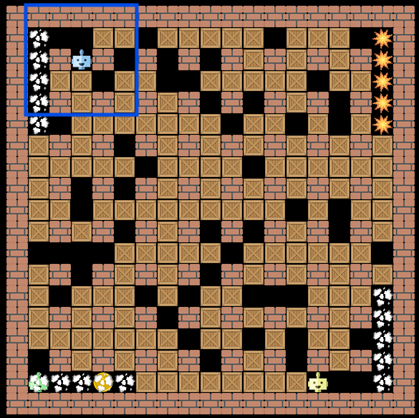
Figure 4: Features type 1

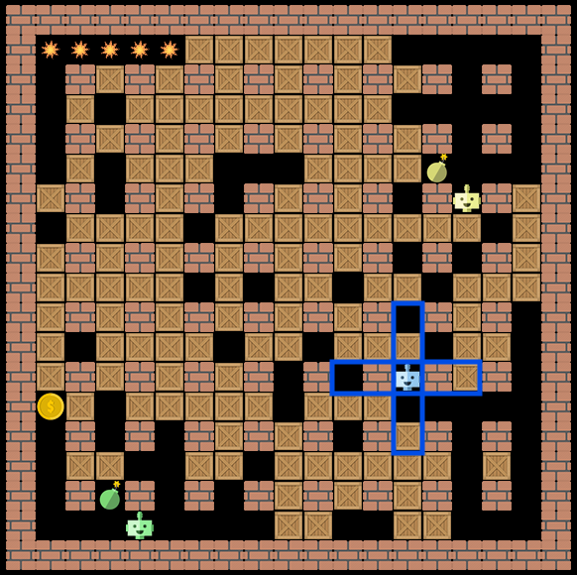
Figure 5: Features type 2

